Exp 3: The stakeholders have conflicting views on the us interface design for an E-Commerce mobile app. Create a prototype using Figma toolto discuss with the stakeholders to get their feedback and approval.

Step 1: Open Figma
- Go to Figma
- Sign in.
- Click New Design File.
Step 2: Create a Mobile Frame
- Press F.
- Select Phone → iPhone 14.
- Rename the frame Home Screen.
Step 3: Create Home Screen
Use Text Tool (T) and type: Shop Easy
Add:
- Search Bar
- Cart Icon
- Profile Icon
Add Banner
Text: Big Sale - Up to 50% Off
Add Categories
Create 4 small boxes:
Electronics
Fashion
Shoes
Books
Add Product Cards: Create 2 product cards.
Product 1
Wireless Headphones
₹1,999
Add to Cart

Product 2
Running Shoes
₹2,499
Add to Cart

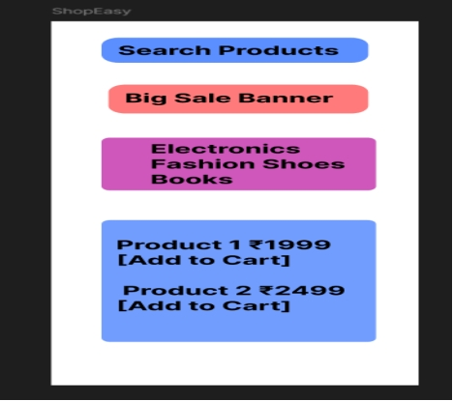

Step 4: Create Product Details Screen
- Press F.
- Create another mobile frame.
- Rename it Product Details.
Add Product Image: Draw a large rectangle.
Add Details:
Wireless Headphones
Price: ₹1,999
Rating: ★★★★☆
Description:
High-quality wireless headphones.
Add Button: Buy Now

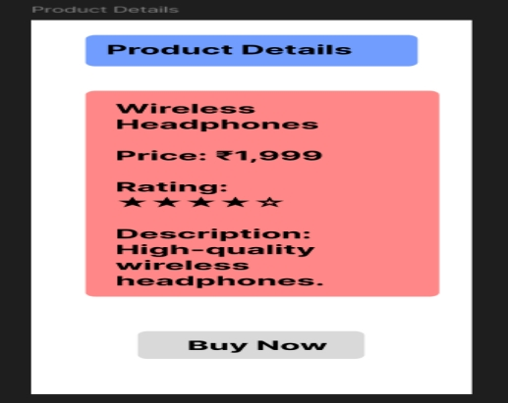
Step 5: Create Cart Screen
Create a new frame.
Title: Shopping Cart
Add:
Wireless Headphones
₹1,999
Quantity: 1
Button: Checkout

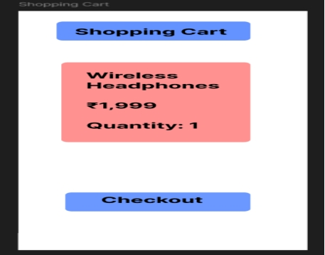

Step 6: Create Checkout Screen
Create another frame.
Fields:
Name
Address
Phone Number
Payment Options:
UPI
Card
Cash on Delivery
Button: Place Order
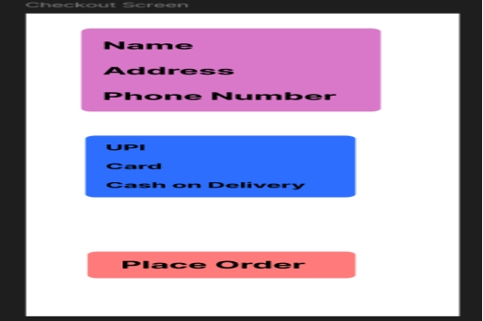

Step 7: Create Order Confirmation Screen
Create another frame.
Add: ✓ Order Placed Successfully
Order ID: ORD12345
Estimated Delivery:3 Days
Button: Continue Shopping
